Monday | Tuesday | Wednesday | Thursday | Friday
- Calendar – What day is it today? Tomorrow? Yesterday? | - Calendar – What day is it today? Tomorrow? Yesterday? | - Calendar – What day is it today? Tomorrow? Yesterday? | - Calendar – What day is it today? Tomorrow? Yesterday? | Song:  - ‘Days of the Week’
Phonics: New  ‘th’ sound – stick tongue out slightly between teeth.  (YouTube:’ Little Learners’) | Phonics:  ‘th’ sound. | Phonics:  ‘th’ sound. | Phonics:  ‘th’ sound. | Phonics:  ‘th’ sound.
Writing Activity:  Think of 3 ‘th’ words, write them and draw picture for each.  (write numbers 1 – 3 beside each word) | Writing Activity:  Think of 5 ‘th’ words, write them and draw picture for each.  (write numbers 1 – 5 beside each word) | Writing Activity:  Orally put these words into a simple sentence and then write them e.g. “I had a bath”.  - three  - thin  - think | Writing Activity:  Pick 4 words from the word list attached and put them into simple sentences. | Writing Activity:  Free writing – write 3 - 4 sentences about whatever topic you like e.g. your day; your house; T.V. programme, etc.
Song of the Week: New  It’s a Beautiful Day  (Singing Walrus) | Song of the Week:  It’s a Beautiful Day  (Singing Walrus) | Song of the Week:  It’s a Beautiful Day  (Singing Walrus) | Song of the Week:  It’s a Beautiful Day  (Singing Walrus) | Song of the Week:  It’s a Beautiful Day  (Singing Walrus)
Maths: New  Think about number 5 –where do we see 5? (five fingers, five toes)  Gather sets of 5 e.g. pegs, socks, crayons, etc.  https://ie.ixl.com/math/jr-infants/learn-to-count-up-to-5 | Reading:  Read short story attached, orally complete the activities. | Maths:  Draw sets of 5, put a ring around each set and colour.  Practise writing number 5 – see rhyme below. | Reading:  Read short story attached, orally complete the activities. | Maths:  Draw 1 circle; 2 apples, 3 flowers; 4 triangles and 5 trees.
Jolly Phonics word list (attached) | Jolly Phonics word list | Jolly Phonics word list | Jolly Phonics word list | Jolly Phonics word list
Now and Then – Ask an adult at home about when they went to school. What was different? What was the same?  Draw your favourite day at school. | P.E. Challenge – 10 star jumps; 3 laps of your garden/sitting room; 10 squats (pretend to sit on chair & stand up); pencil roll across the floor – try to complete in 60seconds | Print – using paint, print various objects onto paper e.g. hand, fruit, key, sponge.  Or  If no paint, trace around various objects with your pencil. | Cosmic Yoga: “Arnold the Ant”  (YouTube) | Zumba Kids: ‘Electronic Song - Minion Dance’  (YouTube)

Links to Videos
Phonics:  - ‘th’: https://www.youtube.com/watch?v=7f74GArsWis  - All Jolly Phonics Songs: https://www.youtube.com/watch?v=U2HYM9VXz9k | Songs & Rhymes:  - Days of the Week: https://www.youtube.com/watch?v=mXMofxtDPUQ  - It’s a Beautiful Day: https://www.youtube.com/watch?v=Iw8FddccIkQ
Cosmic Yoga:  - Arnold the Ant: https://www.youtube.com/watch?v=iWowDC3x0hE | Zumba Kids:  Electronic Song - Minions: https://www.youtube.com/watch?v=FP0wgVhUC9w

Jolly Phonics Word List
Practise reading these words all week. On Thursday and Friday, they can read each word and write it.
nap
tan
set
hill
hand
sand
men
elf
snip
ram

Number 5 formation rhyme:

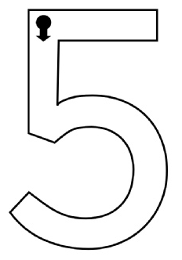

five
Down and around, and then you stop.
To finish a 5 put a line at the top.

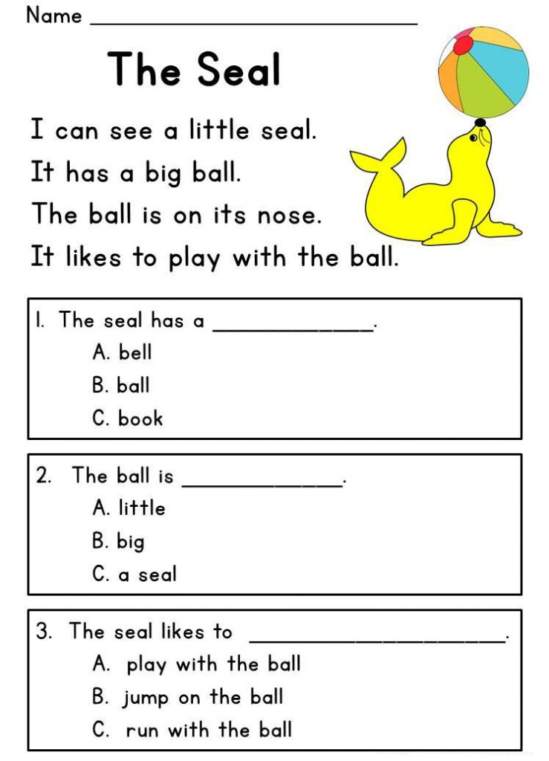
Reading Activity 1:

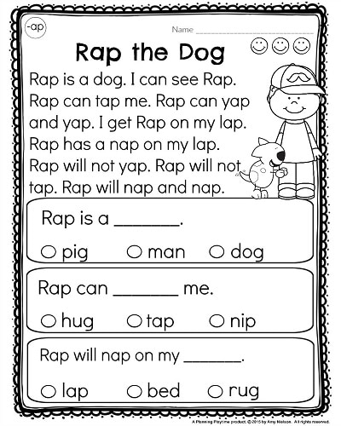
Reading Activity 2:

