St. Ronan’s is here to enable children, parents and teachers to work together in a secure environment where children can enjoy learning and achieve their full potential so they are ready for life and become confident, competent, responsible and happy members of their community.
Our school has a long tradition of parents and teachers working together for the good of the children. Our STAR code of behaviour is another stage in this process.
The system is based on a positive approach to discipline. Children are awarded for being well behaved. We want them to “Reach for the Stars”. This puts the spotlight on good effort and behaviour and removes it from negative behaviour.
The rules are printed and displayed in every classroom. They are based on the code of behaviour worked out by the working committee of parents and teachers.
The emphasis is on the positive. In our infant classes children are given a star every day.
When rules are broken, children are penalised. The penalties are known as sanctions. There are six steps in the sanctions process which are outlined later.
Our belief is that by rewarding good behaviour and effort, a more positive learning atmosphere will be created. School will be a happier and more productive experience for our children. We can all work together to achieve the aims set out above.
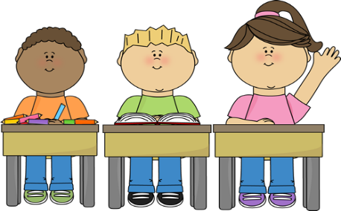
Junior Rules

Classroom Rules

- Be on time, be ready for school. Uniform or navy tracksuit for P.E.
- Do as your teacher tells you.
- Always try your best.
- Listen to the person who is talking.
- Be kind to others.
- Stay in your place when teacher is out of the room.
- Homework must be done.

Out of Class Rules
- You must have permission to be out of class.
- Walk quietly in the corridors.
- Tell the teacher if someone hurts you in the yard.
- Stay in your own yard and line up properly.
- Do as teacher tells you.
- Line up quietly near your door before class.
- At hometime stay in your line until you have given your teacher a “High Five”.
- Walk on the footpath, NEVER go into the carpark.
What the rules mean

Classroom Rules
Rule 1: Be on time, be ready for school.
- Being on time means being in at 8.50 a.m.
- Being prepared means wearing the full school uniform including tie or navy tracksuit and runners for P.E.
- Girls can wear grey trousers if they wish.
- No jewellery or footwear which constitutes a danger to oneself or others may be worn.
- No make – up, nail varnish or false nails.
- Notes must be supplied following an absence, if a child is late and for permission to leave early.
Rule 2: Do as your teacher tells you.
- This applies to all teachers/adults in charge.
- Chewing gum is not allowed in school or on yard.
Rule 4: Listen to the person who is talking.
- Listen attentively to the person speaking and put your hand up if you want the teacher’s attention.
Rule 6: Stay in your place when teacher is out of the
room.
- Children may go to the toilet etc. when given permission by the supervising teacher.
Rule 7: Homework must be done.
- Homework/Reading must be completed, checked and signed.
Out of Class Rules
Rule 4: Stay in your own yard and line up properly.
- In the yard stay on the correct side. Do not cross the yellow line. NEVER leave the yard without permission. Try to remember to go to the toilet before going to the yard. Ask for permission if you have to go to the toilet during yard time.
- To collect your child during yard time parents must call to the secretary’s office to get an orange card which must be presented to the teacher on yard

Rule 7: At hometime stay in your line until you have
given your teacher a “High Five”.
- At hometime teachers want to ensure that children are collected safely. Each child must “High Five” their teacher before leaving their line.

Rewards

_{Star Charts}

- Each class at the infant level will have their own star chart on display in their classroom.

- Each day a child is present he/she will receive one star in the morning. The child is motivated to retain this star by following the classroom rules.
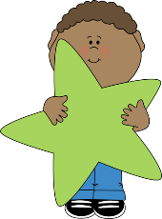
Rewards are given on Friday

5 stars – a lollipop, a sweet and name entered in class
raffle for Lucky Dip.
4 stars – a sweet
Star of the Week

Each Friday one child will be given a certificate for being the Star of the Week.

Infant Lining Up
Award System

- When the Infants have lined up in the yard after the bell has rung, the teacher on duty will select one line from Junior Infants and one line from Senior Infants as the best lines. The teacher will then award these classes with a ladybird badge. One ladybird is awarded at break time and another at lunch time.
- The ladybirds are then placed on a chart in the hallway. On Friday, the Principal will announce the winning lines to the whole school. The winning classes will be awarded with a trophy, a certificate for their classroom door and a sweet for each child.

Sanctions
Step 1 – Verbal warning.
Step 2 – Red warning card on the child’s desk.
Step 3 – Child’s photo/name placed on the “Last Chance”
sad face on display in the classroom.
Step 4 – Child loses their star from the star chart.
Step 5 – Child is sent with work to partner teacher’s
classroom.
Step 6 – For very serious misbehaviour parents/guardians
may be contacted and asked to take their child
home.

On Yard
Children who misbehave on yard may be given a time out. For instances of extreme misbehaviour children may be removed from yard. A child who continuously misbehaves on yard may be kept in the school and miss their break times.

Note: In a case of gross misbehaviour or continued serious misbehaviour the child may be taken to see the Principal.

