ANXIETY- Information for Parents
What is Anxiety?
Anxiety is a normal and healthy reaction to a stressful situation. Feeling anxious is very common. All teenagers experience some amount of anxiety at times.

Some anxiety or stress can be positive as it makes us more alert and helps us perform better. It can help us deal with tense or challenging situations. Young people often feel anxious when they are starting a new school, sitting an exam, competing in sporting events, public speaking, meeting new people, going on a date etc.

Remember. It is okay if your son/daughter experiences some anxiety. You can reassure them that anxiety is normal and something they can cope with. Let them know that what they are feeling is okay and it is helpful to talk about how they are feeling.

Anxiety is only healthy and helpful if it is short lived. It is a problem when your son/daughter is worried and anxious a lot of the time. It is also a problem when there is no obvious reason for them to feel anxious or stressed.

You should be concerned when the anxiety that your son/daughter is experiencing is impacting significantly on their day to day functioning as follows:
- they are too worried or anxious about insignificant situations
- they are feeling constantly keyed up

- when your coaxing or reassurance have no effect
- they are over-sensitive and irritable
- they have unexplained outbursts
- they are restless and can’t concentrate
- they are preoccupied and obsessed about a particular issue
- they withdraw from friends, family, school, work, sports or other things that they usually enjoy
- their sleep is disturbed sleep – either not getting enough or sleeping too much
- they are eating less than normal or overeating
- they don’t care about their personal appearance or personal responsibilities
- their school work has deteriorated

In these instances anxiety is not protecting them, but rather preventing them from fully participating in typical activities of daily life-school, friendships, academic performance.

Causes of Anxiety
There are many things that cause anxiety. Anxiety is individual i.e. what causes one person anxiety may not affect another.

Symptoms of Anxiety
Anxiety affects people in different ways. It can affect the way people feel (Physical Symptoms), think (Mental Symptoms) and behave (Behavioural Symptoms).
The Physical Symptoms of anxiety can be very frightening. People often worry that there is something physically wrong with them.

This worry increases the anxiety and causes symptoms like the following to worsen:

Physical Symptoms  - Racing heart  - Shortness of breath  - Dizziness  - Tingling sensation, pins and needs (particularly in hands)  - Blurred vision  - Sound distortion  - Nausea  - Dry mouth, difficulty swallowing  - Sweating or trembling  - Headaches  - Diarrhoea  - Skin rashes or flare ups  - Butterflies in stomach  - Chest/stomach pains  - Loss of appetite | Behavioural Symptoms  - Avoiding places  - Avoiding people and social situations  - Constantly seeking reassurance  - Excessive drinking/smoking/eating  - Difficulty sleeping/nightmares  - Increased irritability  Mental Symptoms  - Difficulty concentrating  - Difficulty making decisions  - Forgetfulness  - Distorted or irrational thoughts  - Excessive worrying  - Thinking negatively

If your son/daughter experiences some of the above for a couple of weeks or longer, it’s important that you take action. Although it won’t happen overnight, your son/daughter can learn to manage and reduce their anxiety.

How to Help Someone to Reduce their Anxious Feelings

There is no single technique to manage anxiety. However there are a number of techniques that when used together will reduce anxiety. Remember change takes time. Be prepared for ups and downs.

Remember the Basics!
- Encourage your son/daughter to talk to friends, family, the Guidance Counsellor or teachers about how they are feeling
- Encourage them to get enough sleep by leaving their phone/laptop outside their bedroom; avoiding caffeine and sugar before sleeping; avoiding long weekend lie-ins. A minimum of 8 to 9 hours sleep on school nights is recommended for teens
- Explain to them that what they eat or drink can impact on how they feel. Avoid caffeine and energy drinks as they can increase anxious feelings. Avoid high sugar content foods as they may experience a sugar crash
- Remind them that exercising will help them to release tension. It also causes the brain to release serotonin which is a hormone that can improve mood. It also will help them to sleep better
- Explain to them that smoking, drinking or taking drugs are often used as a coping mechanism for anxiety but they in fact can make it worse.

Identify the Triggers
Try to encourage them to identify the triggers for their anxiety. By keeping a log of the following:
- When and where do you feel anxious?
- What makes the feelings worse?
- What helps reduce the feelings?

Positive Self-Talk
As we go about our day, we say things to ourselves in our heads about the things that we or others do. This is called self-talk. We choose what we say to ourselves. It is likely that he/she is engaging in negative self-talk. When we are anxious we engage in faulty and irrational thinking which affects the way we feel and behave.
Writing down their thoughts can be a starting point in identifying the negative thoughts. The next step is to challenge these negative thoughts by asking “Is this really true?” and the last step is to replace these negative thoughts with positive, more reassuring ones.
Examples of positive thoughts are:
- I am unique, I can be myself
- I can try harder instead of giving up
- I don’t have to be perfect. I can just try my best
- I have done this before, I know I can do it again
- I am not a fortune teller, I do not know what they are thinking

You can also encourage them to start using the Thoughts Log.

Practicing Relaxation

Practicing relaxation creates the opposite effects to stress and anxiety. It lowers the heart rate, reduces blood pressure and the sweat gland and lowers arousal. There are many relaxation techniques and different things work for different people. By trying some of the following at home (there are lots of free downloadable Mindfulness and Relaxation apps) or attending a local class, your son/daughter can find out what works for them.
- Yoga
- Pilates
- Meditation
- Mindfulness
- Muscular relaxation
- Visualization
- Body Focus
- Deep Breathing Exercises

Remember the Little Things
The Little Things campaign was designed to remind us of the little things that make a big difference to how we feel. It's the little things that can help lift your mood. See below as well as www.HealthPromotion.ie for printed poster and postcard packs.

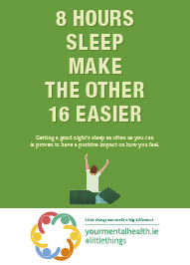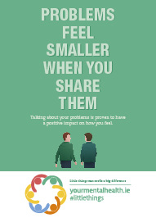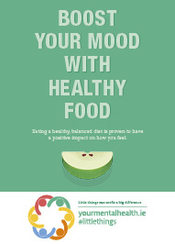
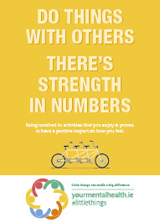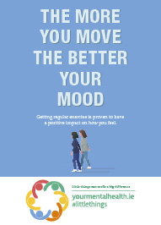

Seek Help
If anxiety is impacting on your son/daughters day-to-day life, they may need short term extra support.
- Encourage them to talk to the Guidance Counsellor at school.
- Encourage them to visit their GP who can support them or refer them on.
- Cognitive Behavioural Therapy (CBT) is very effective in helping people manage anxiety.

Thoughts Log

When we are anxious we engage in faulty and irrational thinking which affects the way we feel and behave. Writing down your thoughts can be a starting point in identifying your negative thoughts. The next step is to challenge these negative thoughts by asking “Is this really true?” and the last step is to replace these negative thoughts with positive, more reassuring ones.

NEGATIVE THOUGHT | POSITIVE THOUGHT

Thoughts Log

NEGATIVE THOUGHT | POSITIVE THOUGHT
Thoughts Log

NEGATIVE THOUGHT | POSITIVE THOUGHT

