ANXIETY – Information for Students

What is Anxiety?
Feeling anxious is a very common feeling that everyone experiences.
It is a normal and healthy response to a stressful situation, a danger or a threat.

Some anxiety or stress can be positive as it makes us more alert and helps us perform better. It can help us deal with tense or challenging situations like starting at post primary, sitting an exam, competing in sporting events, public speaking, meeting new people, going on a date etc. However it is only healthy and helpful if it is short lived.

Anxiety becomes a problem when there is no obvious reason why you feel anxious or stressed. It is also a problem if you are worried and anxious a lot of the time.

Causes of Anxiety
Anxiety is individual i.e. what causes you to be anxious may not affect your friends or members of your family in the same way or at all.

Symptoms of Anxiety
Anxiety affects people in different ways. It can affect the way you feel (Physical Symptoms), the way you think (Mental Symptoms) and the way you behave (Behavioural Symptoms).

The Physical Symptoms of anxiety can be very frightening. People often worry that they are ill or that there is something physically wrong with them. This worry increases the anxiety and causes symptoms like the following to worsen:

Physical Symptoms  - Racing heart  - Shortness of breath  - Dizziness  - Tingling sensation, pins and needs (particularly in hands)  - Blurred vision  - Sound distortion  - Nausea  - Dry mouth, difficulty swallowing  - Sweating or trembling  - Headaches  - Diarrhoea  - Skin rashes or flare ups  - Butterflies in stomach  - Chest/stomach pains  - Loss of appetite | Behavioural Symptoms  - Avoiding places  - Avoiding people and social situations  - Constantly seeking reassurance  - Excessive drinking/smoking/eating  - Difficulty sleeping/nightmares  - Increased irritability  Mental Symptoms  - Difficulty concentrating  - Difficulty making decisions  - Forgetfulness  - Distorted or irrational thoughts  - Excessive worrying  - Thinking negatively

If you experience some of the above for a couple of weeks or longer it’s important that you take action. You don’t have to feel like this. Remember anxiety is very common and can be reduced. Although it won’t happen overnight, you can learn to manage and reduce your anxiety.
Making Anxiety Grow – The Anxiety Monster!
Anxiety is like a hungry monster, the more you feed it, the more it grows! Anxiety can make you avoid doing things that you are afraid of or worried about. When you avoid something you will feel an immediate sense of relief but the next time you will find it even scarier. Avoiding things feeds anxiety and lowers your confidence because we build our confidence by seeing ourselves cope with and manage things. The key is to Feel the Fear and Do It Anyway.

How to Reduce Anxious Feelings
There is no single technique to manage anxiety. However there are a number of things that you can do to reduce your anxiety. Remember change takes time. Be prepared for ups and downs.

Remember the Basics!
- Talk to friends, family, the Guidance Counsellor or teachers about how you are feeling
- Get enough sleep. Leave your phone/laptop outside the bedroom; avoid caffeine and sugar before sleeping; avoid long weekend lie-ins. A minimum of 8 to 9 hours sleep on school nights is recommended for teens
- Have a healthy diet. What you eat or drink can impact on how you feel. Avoid caffeine and energy drinks as they can make you feel more anxious. Avoid high sugar content foods as you may experience a sugar crash
- Keep active. Exercising will help you to release tension. It also causes the brain to release serotonin which is a hormone that can improve your mood. It also will help you sleep better
- Avoid smoking, drinking or taking drugs. These are often used as a coping mechanism for anxiety but they in fact can make it worse.
Identify the Triggers
Try to identify the triggers for your anxiety and then try to identify what helps with the feelings. Keep a log of the following:
- When and where do you feel anxious?
- What makes the feelings worse?
- What helps reduce the feelings?

Positive Self-Talk
As we go about our day, we say things to ourselves in our heads about the things that we or others do. This is called self-talk. We choose what we say to ourselves. It is likely that you are engaging
in negative self-talk. When we are anxious we engage in faulty and irrational thinking which affects the way we feel and behave.
Writing down your thoughts can be a starting point in identifying your negative thoughts. The next step is to challenge these negative thoughts by asking “Is this really true?” and the last step is to replace these negative thoughts with positive, more reassuring ones. See Thoughts Log.
Examples of positive thoughts:
- I am unique, I can be myself
- I can try harder instead of giving up
- I don’t have to be perfect. I can just try my best
- I have done this before, I know I can do it again
- I am not a fortune teller, I do not know what they are thinking

Relaxation Techniques

There are many relaxation techniques and different things work for different people. Practicing relaxation creates the opposite effects to stress and anxiety. It lowers the heart rate, reduces blood pressure and the sweat gland and lowers arousal. There are many relaxation techniques and different things work for different people. By trying some of the following at home (there are lots of free downloadable Mindfulness and Relaxation apps) or attending a local class, you can find what works for you.

- Yoga
- Pilates
- Meditation
- Mindfulness
- Muscular relaxation
- Visualization
- Body Focus
- Deep Breathing Exercises

Remember the Little Things
The Little Things campaign was designed to remind us of the little things that make a big difference to how we feel. It's the little things that can help lift your mood. See below as well as www.HealthPromotion.ie.

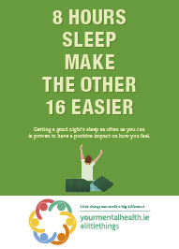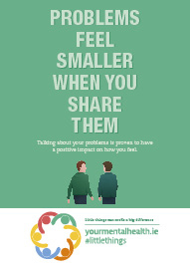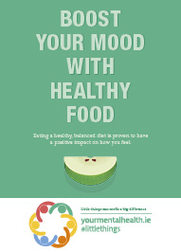
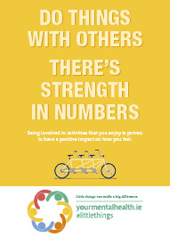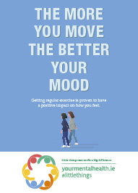

Distraction
It may help to stop thinking about how you are feeling and distract yourself. Focus on what is going on around you – for example if you are in a car, walking etc. and feeling anxious count how many blue cars you see or how many people wearing red etc.
Keep active - Go for walks, do sports, cycle.
Engage the mind in mental games e.g. spell words, count backwards, say the words of a song.

Take Control of your Worries
Remind yourself that although worrying is normal, it is pointless. Instead of wasting your time worrying, take 10 minutes to write down everything you are worried about. Your worries will seem less scary when they are written down and you won’t have to think about them for a while. If you start worrying again, check if what you are worrying about is already written down. If it is not, jot it down. Alternatively if a worry comes into your mind, don’t fight it, rather Notice it, Name it (“I am worrying about X”) and Let it go. By doing this you are refusing to give power to your worries. You will need to practice this.

Problem-Solving
This can help to reduce worries and alleviate stress.
- Write down what the problem is
- Think of all the possible solutions to the problem
- Look at the pros and cons of each solution
- Pick the solution that is best and try it
- After implementing it, ask yourself Did it work?
- If it didn’t move on to the next solution.

Where Can You Get Support
If anxiety is impacting on your day-to-day life, you may need short term extra support.

- Talk to your friends and family
And/Or
- Talk to the Guidance Counsellor at school
And/Or
- Talk to your GP who can support you or refer you on for Cognitive Behavioural Therapy (CBT) which is very effective in helping people manage anxiety
And/Or
- See: www.spunout.ie; www.youth.ie; www.reachout.com.au
And/Or
- Download a Mindfulness and/or Relaxation App.

